

GETTERS AND SETTER’S FUNCTIONS.

BY:

ABDULLAH

(FA22-BCT-004).

SUBMITTED TO:

MA’AM SANEEHA AMIR.



September 24, 2023

COMSATS UNIVERSITY

ISLAMABAD

# **QUESTION#1:**

# **QUESTION#2:**

# **QUESTION#3:**

# **QUESTION#4:**

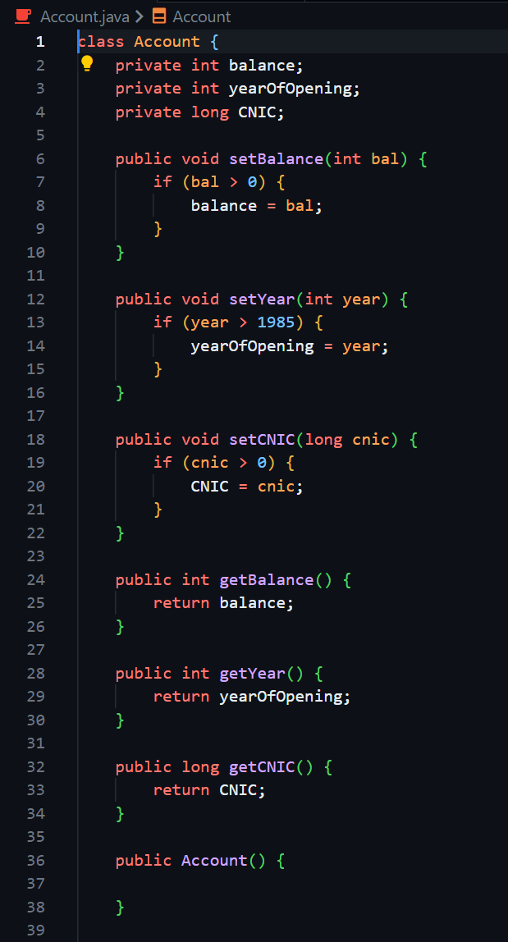

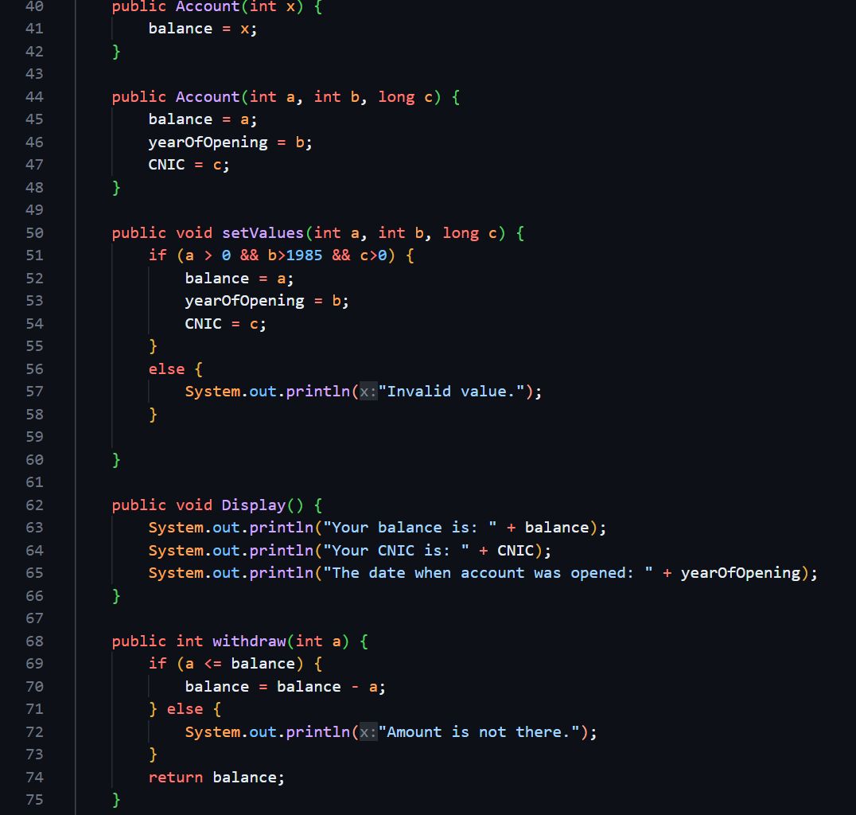

# **QUESTION#5:**

DONE IN QUESTION 3.

# **QUESTION#6:**

DONE IN QUESTION 3.

# **QUESTION#7:**



